


united kingdom & reinsurance
a new paradigm, ebix 2.0v


Functional Specification Document

Document Name | LOAN FORECLOSURE API
Document Version | 1.2
CMS ID | 365546
Client Name | TCL_FSD_LOAN FORECLOSURE API
Product Name | Money ware – Vantage.
Product Version
Created On | 21-Jan-2025
Last Updated On | 28-Mar-2025



Copyright © 2019 EbixCash, all rights reserved.
Statement of Confidentiality
This document contains information that is proprietary and confidential to Miles Software Solution Pvt. Ltd., which shall not be disclosed to any external entity that is not involved in the project and shall not be transmitted, or duplicated, used in whole or in part for any purpose other than its intended purpose. Any use/copy or disclosure in whole or in part of this information without express written permission of Miles Software Solution Pvt. Ltd. is prohibited.

Table of Contents

1.APPROVALS 5
2.DOCUMENT REVISION LOG 6
3. BUSINESS REQUIREMENT 7
4. SCOPE 7
5.OUT OF SCOPE 7
6.DETAILED SOLUTION APPROACH 7
7. Loan Contract closure API 7
7.1. Sample JSON Request 8
7.2. Sample JSON Request Specification details 8
7.3. Validation 8
7.4. Sample JSON Response 9
7.5 Sample JSON Response Specification 9
8. Loan Account close API- New API 10
8.1. Sample JSON Request 12
8.2. Sample JSON Request Specification details 12
8.3. Validations 12
8.4. Sample JSON Response Specification details 12
8.5 Sample JSON Response Specification 13
9.Loan Foreclosure API 14
9.1. Sample JSON Request 14
9.2. Sample JSON Request Specification details 15
9.3. Validations 15
9.4. Response when"Data", 16
9.5. Sample JSON Response Specification details 17
10. Loan Receipt API Existing Enhancement 19
10.1. Sample JSON Request 21
10.2. Sample JSON Request Specification details 21
10.3. Validations 22
10.4. Sample JSON Response 22
10.5. Sample JSON Response Specification details 23
11.Important Points 24
11.1.Front end screen validations 24


1.APPROVALS
This document needs below approvals for implementation.

Author(s) | Name | Date | Comments
Business Analyst | Aman Shegokar | 21-JAN-2025
Reviewed by | Name | Date | Comments
Functional Lead | Summit Sharma
Product Team | Pramod Kumar
Technical Lead | Rajiv Shah
Client Approval | Name | Date | Comments

DOCUMENT REVISION LOG


Document Version No. | Revision Date | Revision Description | Revision made by

3. BUSINESS REQUIREMENT

Business requires three New API.
- Loan Contract Close API
- Loan Account close API.
- Loan Foreclosure API.
- Adding one new field in Loan Receipt API.

4. SCOPE
All the points mentioned in this document fall within the scope of this CR. Anything which is assumed and not explicitly mentioned in the document as part of the solution will be considered out of scope.

5.OUT OF SCOPE
Scope of the document is restricted to the implementation of solution to the above given business requirement and scope is limited to the features provided by Vantage. Any changes derived or assumed to be derived directly or indirectly beyond documented will be considered as out of scope.

6.DETAILED SOLUTION APPROACH
A new API will be developed for the purpose of the loan contract close and loan contract close in the Vantage system. The Loan contract API will identify the current outstanding balances in the loan contract, including due and accrued interest. Loan account close API for determining whether the loan account can be foreclosed.

Loan Contract closure API
This API will be used to close loan contracts (L5). It would be essential to close approved loan contract (L5) by consuming loan contract close API. The sole objective of the API will be for closing loan contract (L5).

- The API is used for retrieving Loan Contract close API, the request is send to Vantage system in the form of JSON request.
- Vantage system will receive request and will provide API response in byte.

API Name | LoanContrat/Closure
URL | http://xxxx/XXXX/VantageWebAPI/api/LoanContractClosure/LoanContractClosure
Method | POST

HTTP headers are required to Authenticate the request. The details required in http header is as follows.
UserID | MilesAPI
Password | deSY7NgwSjl5yqKrK0sNJg==
Content-Type | application/json

Note
- Loan closing Date which is used at the time of loan contract closure will always be current date i.e EOD+1.
- By using the loan contract closure API. The loan contract API will directly close the loan contract and it will be approved automatically without any manual intervention of checker user.

Please refer below screenshot for frontend validation for loan contract close
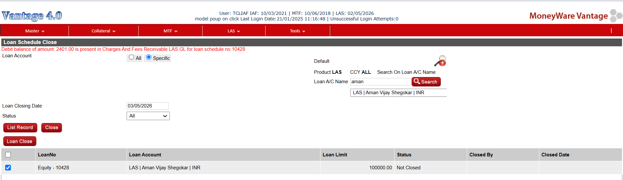

Sample JSON Request

Refer below sample JSON request
{

"LoanContractNo": " "
}

Sample JSON Request Specification details

Refer below table for the field specification
FieldName | DataType(Len) | Mandatory (Yes/No/CM) | Description
LoancontractNO | VARCHAR(50) | Yes | This will be the loan contract number (L5) for which the customer wants to retrieve foreclosure report. This should be available in Vantage system.

Validation

Refer below table for the field specification
S.No | FieldName | Condition | Validation Message
1 | LoancontractNO | If the Loan Contract Number is Blank. | LoancontractNO Is Required,
 |  | .
4 | LoanContractNo | If the loan contract number is invalid. | LoancontractNo is not valid
6 | LoanContractNo | If Loan contract already closed. | This LoancontractNO is already closed.
7 | LoanContractNo | If the loan contract has some outstanding balances. | The loan contract has outstanding balance, cannot be closed.

Sample JSON Response

Refer below the JSON response
{
"CloseContracttData": [
{

"LoanContractNo": "VLASMUM10113",
"RecordStatusCode": "0",
"RespRemarks": "Success"
}
],
"status": {
"Status": "Success",
"Code": "01",
"Remarks": ""
}
}}

7.5 Sample JSON Response Specification

Refer below table for the field specification

FieldName | Datatype(Len  ) | Mandatory | Description
 | )
LoanContractNo | VARCHAR(20) | Yes | This will be the loan contract no..
RecordStatusCode | Numeric(1) | Yes | This will provide information whether the request has been updated in Miles or not.  This will be the status of the received request. A code is passed for the reference in the response. It will have two values, 1 and 0.  1, implies that the record has not been saved in the system due to some data validations or data error. Remarks for the same will be provided in the RespRemarks. In such scenario, data rectification would be required.  0, implies that the record has been saved in the system successfully.
RespRemarks | Varchar(50) | No | This will be the remarks against the JSON request for any data error and validation.  In case the RecordStatusCode is 1, it will show the comma separated validations.  In case the RecordStatusCode is 0, it will show "Success" remarks as remarks.
Status
Status | Varchar(MAX  ) | Yes | This will have following Response  Success : Completed; Failure : Not Completed
Code | Varchar(MAX  ) | Yes | This will have following Codes 01, 02 and 03.  01, implies for Successul response.  02, implies for No data found if something is fetched from the system.  03, implies for failure response for the exceptions at application level, example Syntax Error.
Remarks | Varchar(Max) | No | This will provide remarks in the API failure /successful scenarios.

Loan Account close API- New API

Purpose of API
- The API is used to close loan account, the request is send to Vantage system in the form of JSON request.
- Vantage system will receive request and will provide API response.

API Name | LoanAccountClose/LoanAccountClose
URL | http://xxxx/XXXX/VantageWebAPI/api/LoanAccountClose/LoanAccountClose
Method | POST

HTTP headers are required to Authenticate the request. The details required in http header is as follows.
UserID | MilesAPI
Password | deSY7NgwSjl5yqKrK0sNJg==
Content-Type | application/json

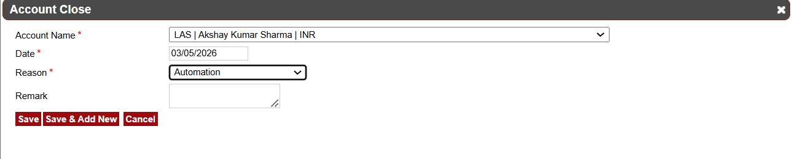

Note
- Loan Date which is used at the time of loan Account closure will always be current date i.e EOD+1.
- By using the loan account closure API. The loan account close API will directly close the loan account.

Please refer below screenshot for frontend validation in Loan account close
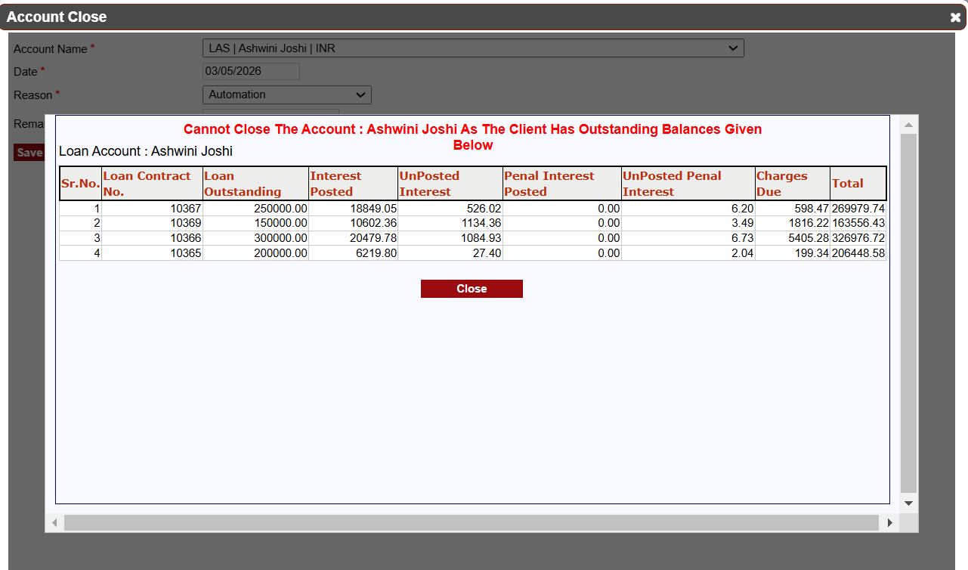

8.1. Sample JSON Request

Refer below sample JSON request
{
"
"LoanAccountNo": " "
}

Sample JSON Request Specification details

Refer below table for the field specification
FieldName | DataType(Len) | Mandatory (Yes/No/CM) | Description
LoanAccountNo | VARCHAR(50) | Yes | This will be the loan account number (L4) for which the customer wants to retrieve foreclosure report. This should be available in Vantage system.

Validations

Refer below table for the field specification

S.No | FieldName | Condition | Validation Message
1 | LoanAccountNO | If the Loan Account Number is Blank. | LoanAccountNo Is Required,
2 | LoanAccountNO | If loan Account Number is closed. | LoanaccountNo is already closed.
3 | LoanaccountNo | If the loan account number is invalid. | LoanaccountNo is not valid.
4 | LoanaccountNo | If some loan contract’s are active. | LoanaccountNo cannot close there are some active loan contracts.
5 | LoanaccountNo | If loan account has some holdings. | Exisitng LoanaccountNo has some holding account cannot be close.
5 | UniqueRecordID | If the unique record ID is Blank. | UniqueRecordID Is Required

Sample JSON Response Specification details

Refer below the JSON response

{
"CloseAccountData": [
{

"LoanAccountNo": "17345324983",
"RecordStatusCode": "0",
"RespRemarks": "Success"
}
],
"status": {
"Status": "Success",
"Code": "01",
"Remarks": ""
}
}

8.5 Sample JSON Response Specification

Refer below table for the field specification
FieldName | Datatype(Len  ) | Mandatory | Description
LoanAccountNo | VARCHAR(20) | Yes | This will be the loan account no.
RecordStatusCode | Numeric(1) | Yes | This will provide information whether the request has been updated in Miles or not.  This will be the status of the received request. A code is passed for the reference in the response. It will have two values, 1 and 0.  1, implies that the record has not been saved in the system due to some data validations or data error. Remarks for the same will be provided in the RespRemarks. In such scenario, data rectification would be required.  0, implies that the record has been saved in the system successfully.
RespRemarks | Varchar(50) | No | This will be the remarks against the JSON request for any data error and validation.  In case the RecordStatusCode is 1, it will show the comma separated validations.  In case the RecordStatusCode is 0, it will show "Success" remarks as remarks.
Status
Status | Varchar(MAX  ) | Yes | This will have following Response  Success : Completed; Failure : Not Completed
Code | Varchar(MAX  ) | Yes | This will have following Codes 01, 02 and 03.  01, implies for Successul response.  02, implies for No data found if something is fetched from the system.  03, implies for failure response for the exceptions at application level, example Syntax Error.
Remarks | Varchar(Max) | No | This will provide remarks in the API failure /successful scenarios.

9.Loan Foreclosure API

- The API will be used for retrieving foreclosure data, the request is send to Vantage system in the form of JSON request.
- Vantage system will receive request and will provide API response format in JSON when requested Data.
- The Foreclosure report will be provided by Vantage system at real time.

API Name | LoanClosure/LoanClosure
URL | http://xxxx/XXXX/VantageWebAPI/api/LoanClosure/LoanClosure
Method | POST

HTTP headers are required to Authenticate the request. The details required in http header is as follows.
UserID | MilesAPI
Password | deSY7NgwSjl5yqKrK0sNJg==
Content-Type | application/json

9.1. Sample JSON Request

To get data in JSON
{
"LoanNo" : "V100LAS00010462",
"Format":"2",
"FromDate":"2023-Sep-09",
"ToDate":"2023-09-30",
"ReportType":"Data"
}

9.2. Sample JSON Request Specification details

FieldName | DataType(Len) | Mandatory (Yes/No/CM) | Description
LoanNo | VARCHAR(50) | Yes | This will be the loan contract number (L5) for which the customer wants to retrieve foreclosure report. This should be available in Vantage system.
Format | VARCHAR(18) | Yes | Format in which the customer wants to retrieve foreclosure report. By default it will be format 2 in this case.  "2" needs to be send in the request.
FromDate | Datetime(18) | Yes | This will be the loan foreclosure date at which customer is generating the foreclosure report.
ToDate | Datetime(18) | Yes | This will be the loan foreclosure date at which customer is generating the foreclosure report.
ReportType | VARCHAR(5) | Yes | Report type in which the customer wants to retrieve foreclosure report.  Expected Value:  - Data  If value is passed as “Data”, data will be generated in the JSON format.

9.3. Validations
S.No | FieldName | Validation Message
1 | LoanNo | Loan No Is Required
2 | FromDate | From Date Is Required
3 | ToDate | To Date Is Required

9.4. Response when"Data",

{
"LoanClosureData": [
{
"AsOnForeclosureDate": "30th September 2023",
"LoanAccountName": "Jagdish Parag Joshi",
"Address": "SaiLeela Apartment,, Nandan Tower, Mumbai, Opp. ICIC Bank, Mumbai, 456678",
"LoanAccNo": "10177",
"LoanContractNo": "V100LAS00010462",
"OutstandingPrincipal": "0.00",
"OutstandingInterest": "4511.09",
"OutstandingCharges": "329.90",
"InterestAccruedNotDue": "297.95",
"TDSReceivable": "1595.18",
"InterestOnClosureDate": "0.00",
"PenalInterestOnClosureDate": "0.00",
"TotalDue": "6734.12",
"ExcessMargin": "0.00",
"TotalCredit": "0.00",
"NetPayable": "6734.12",
"PayableForNext7Days": [
{
"Day1ClosureDate": null,
"Day1ClosureAmount": "0.00",
"Day2ClosureDate": null,
"Day2ClosureAmount": "0.00",
"Day3ClosureDate": null,
"Day3ClosureAmount": "0.00",
"Day4ClosureDate": null,
"Day4ClosureAmount": "0.00",
"Day5ClosureDate": null,
"Day5ClosureAmount": "0.00",
"Day6ClosureDate": null,
"Day6ClosureAmount": "0.00",
"Day7ClosureDate": null,
"Day7ClosureAmount": "0.00"
}
]
}
],
"status": {
"Status": "Success",
"Code": "01",
"Remarks": ""
}
}

9.5. Sample JSON Response Specification details
FieldName | DataType(Len) | Mandatory(Y es/No/CM) | Description
LoanClosureData
AsOnForeclosure  Date | Date | No | This is the date as on for the closure date.  Date format : DD-MMM-YYYY
LoanAccountNam  e | VARCHAR(50) | No | This will be the (Loan Account) Client Name
Address | VARCHAR(Max) | No | This will be address of the client. The address will be concatenated as per the client statement.
LoanAccountNo | VARCHAR(50) | No | This will be Vantage System Loan Account Number L4
LoanContractNo | VARCHAR(50) | No | This will be the loan contract no. that will be generated and sent in response from Miles system. This will be the system generated incremental number L5.
OutstandingPrinci pal | numeric(18,2) | No | Total current principal outstanding for the loan contract (L5).
OutstandingInter est | numeric(18,2) | No | Total current interest outstanding for the loan contract (L5).
OutstandingCharg es | numeric(18,2) | No | Total current charges outstanding for the loan contract
InterestAccruedn otdue | numeric(18,2) | No | Total interest accrued not due till date for the loan contract (L5).
TDSReceivable | numeric(18,2) | No | Total TDS amount for the loan account.

InterestonClosure  Date | numeric(18,2) | No | Total Interest Outstanding on Closure Date for the loan Contract
PenalInterestonCl osureDate | numeric(18,2) | No | Total Penal Interest Outstanding on Closure Date for the loan Contract
TotalDues | numeric(18,2) | No | This will be sum total of all the outstandings and dues for the loan contract like Interest, Penal Interest, Charges etc
ExcessMargin | numeric(18,2) | No | Total current execess margin available at loan contract (L5).
TotalCredit | numeric(18,2) | No | Total Credit Available for the client
NetPayable | numeric(18,2) | No | This is Total Dues - (Advance interest +Excess  Margin)
PayableForNext7
Days
Day1ClosureDate | Date | No | This is the Day 1 closure date i.e. (AsOnClosureDate  +1). Date format : DD-MMM-YYYY
Day1ClosureAmo unt | numeric(18,2) | No | This will be total amount payable for loan contract closure on 1st day
Day2ClosureDate | Date | No | This is the Day 2 closure date i.e. (AsOnClosureDate  +2). Date format : DD-MMM-YYYY
Day2ClosureAmo unt | numeric(18,2) | No | This will be total amount payable for loan contract closure on 2nd day
Day3ClosureDate | Date | No | This is the Day 3 closure date i.e. (AsOnClosureDate  +3). Date format : DD-MMM-YYYY
Day3ClosureAmo unt | numeric(18,2) | No | This will be total amount payable for loan contract closure on 3rd day
Day4ClosureDate | Date | No | This is the Day 4 closure date i.e. (AsOnClosureDate  +4). Date format : DD-MMM-YYYY
Day4ClosureAmo unt | numeric(18,2) | No | This will be total amount payable for loan contract closure on 4th day
Day5ClosureDate | Date | No | This is the Day 5 closure date i.e. (AsOnClosureDate  +5). Date format : DD-MMM-YYYY
Day5ClosureAmo unt | numeric(18,2) | No | This will be total amount payable for loan contract closure on 5th day
Day6ClosureDate | Date | No | This is the Day 6 closure date i.e. (AsOnClosureDate  +6). Date format : DD-MMM-YYYY
Day6ClosureAmo unt | numeric(18,2) | No | This will be total amount payable for loan contract closure on 6th day
Day7ClosureDate | Date | No | This is the Day 7 closure date i.e. (AsOnClosureDate  +7). Date format : DD-MMM-YYYY
Day7ClosureAmo unt | numeric(18,2) | No | This will be total amount payable for loan contract closure on 7th day
StatusData
Status | Varchar(MAX) | Yes | This will have following Response Success :  Completed; Failure : Not Completed
Code | Varchar(MAX) | Yes | This will have following Codes 01, 02 and 03. 01, implies for Successul response. 02, implies for No data found if something is fetched from the system. 03, implies for failure response for the exceptions at application level, example Syntax Error.
Remarks | Varchar(MAX) | Yes | This will provide remarks in the API failure /successful scenarios.

Loan Receipt API Existing Enhancement

API Name | LoanReceipt/SaveLoanReceipt
URL | http://xxxx/XXXX/VantageWebAPI/api/LoanReceipt/SaveLoanReceipt
Method | POST

HTTP headers are required to Authenticate the request. The details required in http header is as follows.

UserID | MilesAPI
Password | deSY7NgwSjl5yqKrK0sNJg==
Content-  Type | application/json

Please refer below the screenshot for loan receipt screen
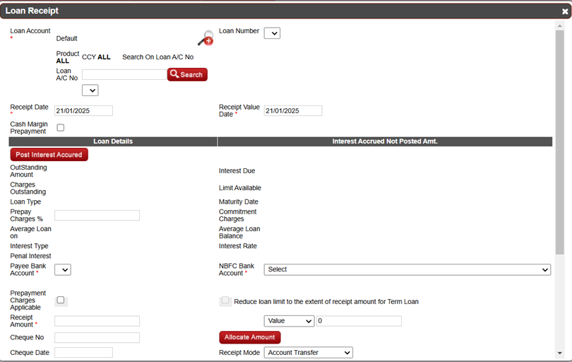
Enhancement
- The "Transaction Type" key parameter will be non-mandatory and will accept two values:
- i)Receipt Posting ii) Manual Posting
- If the "Transaction Type" is passed as blank, it will still be considered as a receipt
- If the "Transaction Type" is set to Receipt Posting, it will be treated as a receipt posting.
- For Manual Posting, only the "Loan Schedule" field will be mandatory; other key fields should be left blank.
- If the accrued interest is zero, a validation message should appear stating: "There is no accrued interest for posting.

10.1. Sample JSON Request

Refer below sample JSON request

[
{
"TransactionType ": "Receipt",
"LoanScheduleNo": "114455",
"NBFCBankAccountName": "HDFC BANK - BILLDESK CONTROL ACCOUNT - 164051",
"NBFCBankAccountNo": "164051",
"ReceiptAmount": "2000",
"ReceiptDate": "2024-07-08",
"ReceiptMode": "R",
"ReceiptValueDate": "2024-07-08",
"RefNo": "870662499131539",
"UniqueRecordID": "551627211"
}
]

10.2. Sample JSON Request Specification details

Refer below table for the field specification

FieldName | DataType(Len  ) | Mandatory (Yes/No/CM) | Description
TransactionType | VARCHAR(50) | No | Transaction type  Receipt Posting  ManualPosting
LoanScheduleNo | VARCHAR(25) | Yes | Loan contract Number L5 for which customer is making online payment
ReceiptValueDate | VARCHAR(25) | Yes | Actual receipt transaction date
ReceiptDate | VARCHAR(25) | Yes | Loan Repayment Date as EOD +1 date (Current date)
ReceiptAmount | NUMERIC(18,  2) | Yes | Amount which customer has given repaid
NBFCBankAccountNo | VARCHAR(50) | Yes | NBFC Bank Account number in which the customer has made repayment.
NBFCBankAccountNam  e | VARCHAR(50) | yes | NBFC Bank Account's Bank name in which the customer has made repayment.
RefNo | VARCHAR(50) | Yes | Cheque UTR NEFT TRF
ReceiptMode | VARCHAR(20) | Yes | "M" - Manual Cheque  "C" - Cheque Payments  "D" - Draft Payments  "I" - Account/Fund Transfer  "H" - Pay Order  "R" - RTGS Payments  "N" - NEFT Payments  "P" - Remote Cheque Printing  "T" - Transfer Letter  "CA" – Cash
UniqueRecordID | VARCHAR(25) | Yes | Unique ID generated for each record.

Validations

Refer below table for the field specification

Sr.NO | Field Name | Condition | Validation
1 | TransactionType | If wrong parameter passed in Transactiontype | Accrued charges cannot be passed due to invalid transaction name,
2 | TransactionType | If transaction type passed manual posting and accrued interest “0”. | No accrued interest for posting.

Sample JSON Response

Refer below the JSON response
{
"SaveReceiptData": [
{
"LoanAmount": "0.00",
"InterestAmount": "0.00",
"RecordStatusCode": "1",
"ExcessAmount": "0.00",
"PenalInterestAmount": "0.00",
"UniqueRecordID": "2994820",
"Remarks": " ",
"ChargesAmount": "0.00"
}
],
"status": {
"Status": "Success",
"Remarks": "",
"Code": "01"
}
}

Sample JSON Response Specification details

Refer below table for the field specification
FieldName | DataType(Len  ) | Mandatory  (Yes/No/CM  ) | Description
SaveReceiptData
UniqueRecordID | Varchar(25) | Yes | This is the unique required ID passed in the request.
RecordStatusCode | Numeric(1) | Yes | This will provide information whether the request has been updated in Miles or not.  This will be the status of the received request. A code is passed for the reference in the response. It will have two values, 1 and 0.  1, implies that the record has not been saved in the system due to some data validations or data error. Remarks for the same will be provided in the RespRemarks. In such scenario, data rectification would be required.  0, implies that the record has been saved in the system successfully.  Expected Values:  - 1  - 0
LoanAmount | Numeric(18,2) | Yes | Total amount repaid against principal O/S.
InterestAmount | Numeric(18,2) | No | Total amount repaid against Interest O/S.
PenalInterestAmoun t | Numeric(18,2) | No | Total amount repaid against penal Interest O/S.
ExcessAmount | Numeric(18,2) | No | Total amount repaid against Excess Margin.
ChargesAmount | Numeric(18,2) | No | Total amount repaid against Charges O/S.
Remarks | VarChar(50) | No | This will be the remarks against the JSON request for any data error and validation.  In case the RecordStatusCode is 1, it will show the comma separated validations.  In case the RecordStatusCode is 0, it will show "Success" remarks as remarks.
Status
Status | Varchar(MAX) | Yes | This will have following Response  Success : Completed; Failure : Not Completed
Code | Varchar(MAX) | Yes | This will have following Codes 01, 02 and 03.  01, implies for Successul response.  02, implies for No data found if something is fetched from the system.  03, implies for failure response for the exceptions at application level, example Syntax Error.  Expected Values:  1. 01  2. 02  3. 03
Remarks | Varchar(Max) | No | This will provide remarks in the API failure /successful scenarios.

10.6.Sample JSON request

[
{
"TransactionType ": "ManualPosting",
"LoanScheduleNo": "114455",
"NBFCBankAccountName": "HDFC BANK - BILLDESK CONTROL ACCOUNT - 164051",
"NBFCBankAccountNo": "164051",
"ReceiptAmount": "",
"ReceiptDate": "2024-07-08",
"ReceiptMode": "R",
"ReceiptValueDate": "2024-07-08",
"RefNo": "870662499131539",
"UniqueRecordID": "551627211"
}
]

10.2. Sample JSON Request Specification details

Refer below table for the field specification

FieldName | DataType(Len  ) | Mandatory (Yes/No/CM) | Description
TransactionType | VARCHAR(50) | No | ManualPosting
LoanScheduleNo | VARCHAR(25) | Yes | Loan contract Number L5 for which customer is making online payment
ReceiptValueDate | VARCHAR(25) | Yes | Actual receipt transaction date
ReceiptDate | VARCHAR(25) | Yes | Loan Repayment Date as EOD +1 date (Current date)
ReceiptAmount | NUMERIC(18,  2) | Yes | Amount which customer has given repaid
NBFCBankAccountNo | VARCHAR(50) | Yes | NBFC Bank Account number in which the customer has made repayment.
NBFCBankAccountNam  e | VARCHAR(50) | Yes | NBFC Bank Account's Bank name in which the customer has made repayment.
RefNo | VARCHAR(50) | NO | Cheque UTR NEFT TRF
ReceiptMode | VARCHAR(20) | Yes | "M" - Manual Cheque  "C" - Cheque Payments  "D" - Draft Payments  "I" - Account/Fund Transfer  "H" - Pay Order  "R" - RTGS Payments  "N" - NEFT Payments  "P" - Remote Cheque Printing  "T" - Transfer Letter  "CA" – Cash
UniqueRecordID | VARCHAR(25) | NO | Unique ID generated for each record.

11.Important Points

- By using the loan foreclosure API, user can identify how much value is required to close the loan contract. It will also indicate whether the account is eligible for foreclosing the loan contract.
- By using the loan contract API. The loan contract API will directly close the contract and it will approved automatically.
- The existing validations will remain the same on the click of the validation.
- In the loan receipt API, when the transaction type is "manual posting," the changes in the API will directly post and approved automatically.
- In the loan receipt API, if the transaction type is passed as blank, it will automatically consider it as receipt posting, and charges will be calculated according to receipt posting.
- For manual posting, the "post interest till date" will be the last EOD (End of Day) date.
- The existing checks and validations for the Loan Contract Close and Loan Account Close screens will also be available in the API.
- Newly added field should populate in DWH table.

11.1.Front end screen validations

Refer below menu and the navigation path for the enhancement
Menu Name: LAS (Loan Contract close)
Menu Navigation: LAS Loan Loan Contract close


Refer below menu and the navigation path for the enhancement
Menu Name: Master (Loan Account)
Menu Navigation: Master Loan Loan Account Account close


- The existing front end screen validation will remain same.

